Assignment 6 :
GitHub Link :
README.md Link :

Question : Design and simulate a sequence detector for detecting '1001'.
- Draw the Mealy FSM state diagram.
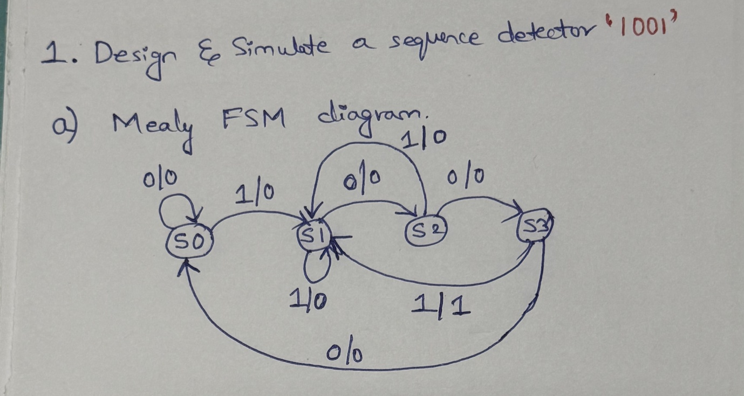

- Implement the Mealy FSM in Verilog HDL.

Verilog Code :

`timescale 1ns/1ps

module mealy_fsm_detect_1001 (
input wire clk,
input wire reset,
input wire data_in,
output reg detected
);

localparam [1:0] S0 = 2'b00,
S1 = 2'b01,
S2 = 2'b10,
S3 = 2'b11;

reg [1:0] PS, NS;

always @(posedge clk or posedge reset) begin
if (reset)
PS <= S0;
else
PS <= NS;
end

always @(PS or data_in) begin
NS = S0;

case (PS)
S0: begin
NS = data_in ? S1 : S0;
end

S1: begin
NS = data_in ? S1 : S2;
end

S2: begin
NS = data_in ? S3 : S0;
end

S3: begin
NS = data_in ? S1 : S0;
end

default: NS = S0;
endcase
end

always @(PS or data_in) begin
case (PS)
S0, S1, S2: detected = 1'b0;
S3: detected = data_in;
default: detected = 1'b0;
endcase
end

endmodule

- Draw the Moore FSM state diagram.

Non-Overlapping Case :
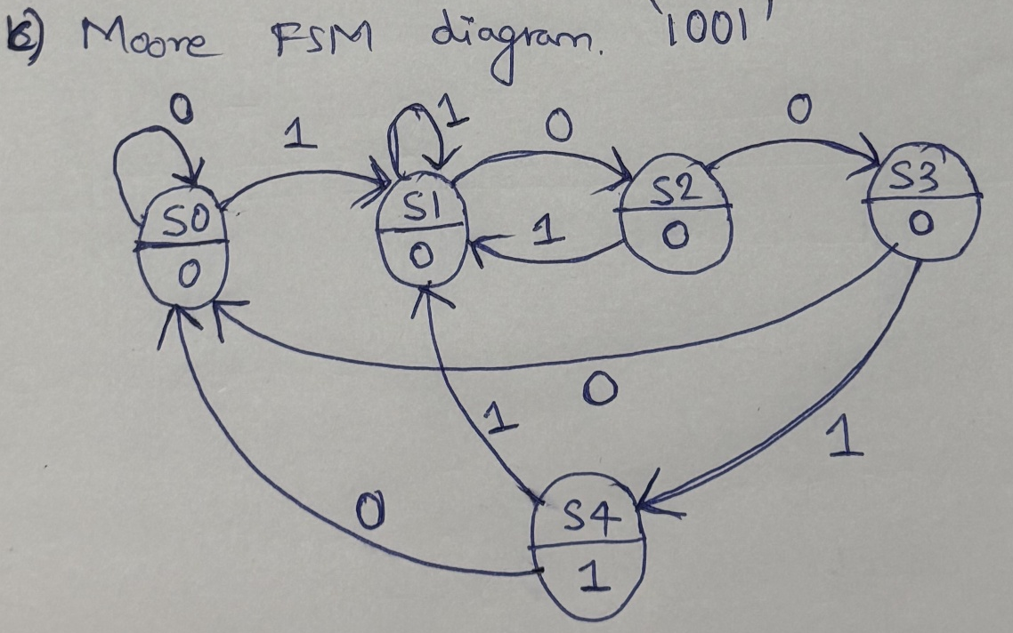

Verilog Code :
`timescale 1ns/1ps

module moore_fsm_detect_1001_nonoverlap (
input wire clk,
input wire reset,
input wire data_in,
output reg detected
);

localparam [2:0] S0 = 3'b000,
S1 = 3'b001,
S2 = 3'b010,
S3 = 3'b011,
S4 = 3'b100;

reg [2:0] PS, NS;

always @(posedge clk or posedge reset) begin
if (reset)
PS <= S0;
else
PS <= NS;
end

always @(PS, data_in) begin
NS = S0;

case (PS)
S0: begin
NS = data_in ? S1 : S0;
end

S1: begin
NS = data_in ? S1 : S2;
end

S2: begin
NS = data_in ? S1 : S3;
end

S3: begin
NS = data_in ? S4 : S0;
end

S4: begin
NS = data_in ? S1 : S0;
end

default: NS = S0;
endcase
end

always @(PS) begin
case (PS)
S0, S1, S2, S3: detected = 1'b0;
S4: detected = 1'b1;
default: detected = 1'b0;
endcase
end

endmodule

Overlapping Case :
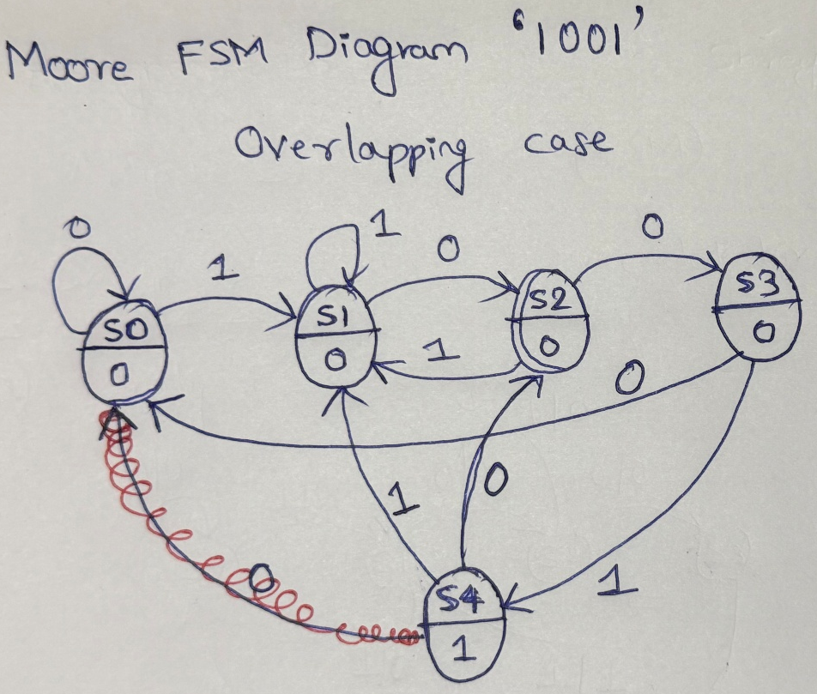

Verilog code :
`timescale 1ns/1ps
module moore_fsm_detect_1001_overlap (
input wire clk,
input wire reset,
input wire data_in,
output reg detected
);

localparam [2:0] S0 = 3'b000,
S1 = 3'b001,
S2 = 3'b010,
S3 = 3'b011,
S4 = 3'b100;

reg [2:0] PS, NS;

always @(posedge clk or posedge reset) begin
if (reset)
PS <= S0;
else
PS <= NS;
end

always @(PS, data_in) begin
NS = S0;

case (PS)
S0: begin
NS = data_in ? S1 : S0;
end

S1: begin
NS = data_in ? S1 : S2;
end

S2: begin
NS = data_in ? S1 : S3;
end

S3: begin
NS = data_in ? S4 : S0;
end

S4: begin
NS = data_in ? S1 : S2;
end

default: NS = S0;
endcase
end

always @(PS) begin
case (PS)
S0, S1, S2, S3: detected = 1'b0;
S4: detected = 1'b1;
default: detected = 1'b0;
endcase
end

endmodule

